

08

Fall

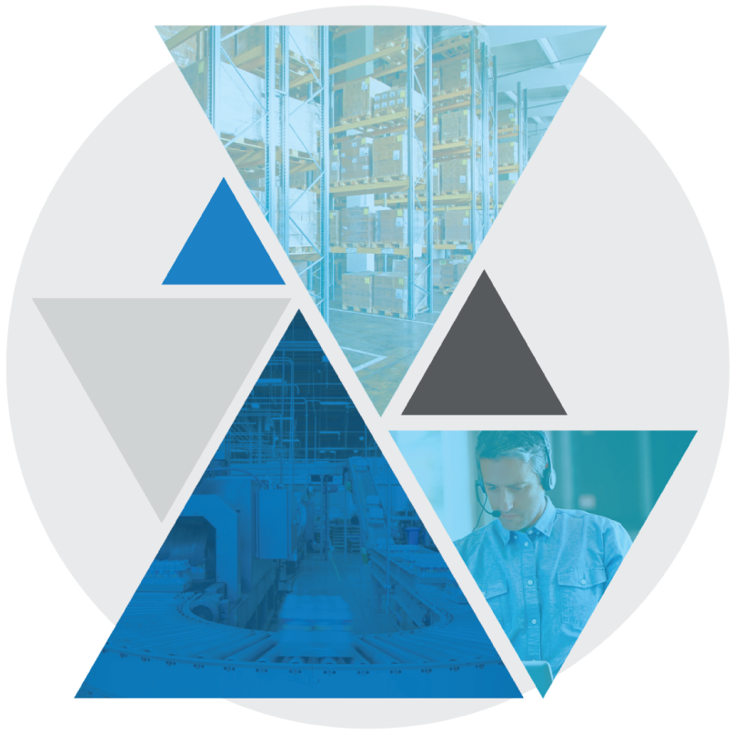

**Test Case: BASE-YRD-8020 API Close Transport Equipment**

Table of Contents

API Close Transport Equipment 3

Test Case Setup 3

Test Case Cleanup 3

Test Case Prerequisites and Assumptions 4

Test Case Examples 4

Test Case Configurations 4

Test Case Verification Approach 4

Test Case Specification 5

API Close Transport Equipment

This document documents the test case instructions for the BASE-YRD-8020 API Close Transport Equipment.

**Please note**: The inputs used in these test case specifications (defined in the input CSV files or Datastore) are relative to our testing warehouse environment and are provided as examples. These inputs should be substituted with valid inputs relative to your WMS environment.

Test Case Setup

* Test Case Background function will run the standard set of setup scenarios for the bundle.
* Test Case Dataset
  + The dataset creates an inbound Transport Equipment, as well as a Planned Inbound Order/Shipment.

Test Case Cleanup

* The Test Case After Scenario will run the standard cleanup actions for the bundle.
* Data created during dataset creation and execution is cleaned up

Test Case Prerequisites and Assumptions

* The Test Case executes without interacting with User Interfaces
* The yard location(s) included in the Test Case Input are valid location(s) in the warehouse
* The client_id and wh_id configured in Environment feature match the data in the Test Case Input and will be used for validation, if they do not match, then define client_id and wh_id in local data override
* The Blue Yonder WMS version is >= 2020.1.1

Test Case Examples

This Test Case will be run with the following examples specified in the Test Case Inputs CSV file:

|  |  |  |
| --- | --- | --- |
| Transport Equipment Number | Planned Inbound Order Number | Yard Location |
| BASE-YRD-8020 | BASE-YRD-8020 | RDCK-006 |

Test Case Configurations

The Test Case will be run in the following test configurations:

* Only Single-Warehouse Configuration Tested

Test Case Verification Approach

This test will verify that the Blue Yonder API exhibits the correct behavior when posting to the /api/yard/v1beta/transportEquipment/<transportEquipmentId>/close endpoint.

Test Case Specification

|  |  |
| --- | --- |
| **Test Case:** BASE-YRD-8020 API Close Transport Equipment | **Description:** API Close Transport Equipment **Functional Area:** Yard **Test Case Type:** Regression **Dataset:** Datasets/Base/Inbound_Trailer **Test Case Inputs:** Test Case Inputs/BASE-YRD-8020.csv **Test Case Detail Input CSV:** None **Duration:** 0.2 minutes |

|  |  |
| --- | --- |
| **Steps, Actions, and Expected Results** | **Supporting information and/or Affected Data** |
| **Step 1**: Determine the Transport Equipment ID of the Transport Equipment created by the dataset.  **Actions**:   * Invokes an API request to retrieve the unique identifier of the Transport Equipment   **Expected Results**:   * If the Transport Equipment cannot be located, or there are multiple Transport Equipment that match the criteria, an error will be thrown. |  |
| **Step 2**: Check In the Transport Equipment  **Actions**:   * Invokes an API request to check the Transport Equipment in to the desired dock door   **Expected Results**:   * The Transport Equipment will be checked in. | No screen data given. Test is not interacting with a user interface |
| **Step 3**: Close the Transport Equipment  **Actions**:   * An HTTP GET request will retrieve JSON data from the Blue Yonder web service * These Postman screenshots are for reference only. The Test Case itself does not interact with any UIs.   **Expected Results**:   * An HTTP response code of “200 OK” indicates that the request was properly authorized and properly formatted. Any other status indicates an error occurred. |  |
| **Step 4**: Verify the result  **Actions**:   * The API will be queried once more to list the transport equipment information. The Transport Equipment Status will be checked * These Postman screenshots are for reference only. The Test Case itself does not interact with any UIs.   **Expected Results**:   * If the status is “CLOSED”, the Test Case succeeds. If the status is not “CLOSED”, the Test Case fails. |  |

|  |  |
| --- | --- |
| **Final State:** Close Transport Equipment is successful | No screen data given. Test is not interacting with a user interface |